Friday 12th February
Writing
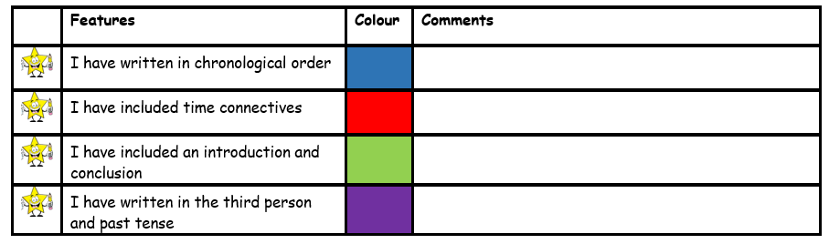
Today you are going to be writing your biography on King Arthur. I have included the subheadings you need to write under. Make sure to look at the success criteria so you remember what you need to include.

Biography of King Arthur
Early Life
King Arthur was the son of King Uther of England. When he was born King Uther gave away King Arthur to a Wizard Named Merlin.Merlin then gave King Arthur to Sir Ector. When King Arthur got older Merlin started visiting him often.

Becoming King
At the age of Fifteen king Arthur became King by pulling the sword out of the stone. Also Sir Kay tried but couldn't take it out, but King Arthur did and was pronounced King.
Personal Life
king Arthur married Guinevere and Lodegrease Guinveres father gave King Arthur a wedding gift that was a round table. Before King Arthur was married he liked a lady called Morgause and they had a son called Mordred.

When he died
King Arthur Lost Excalibur and the magic scabbard and was hit by Mordred in the head. As he was dying he asked for the Excalibur and the scabbard to be returned back to the lake where he got it from.

