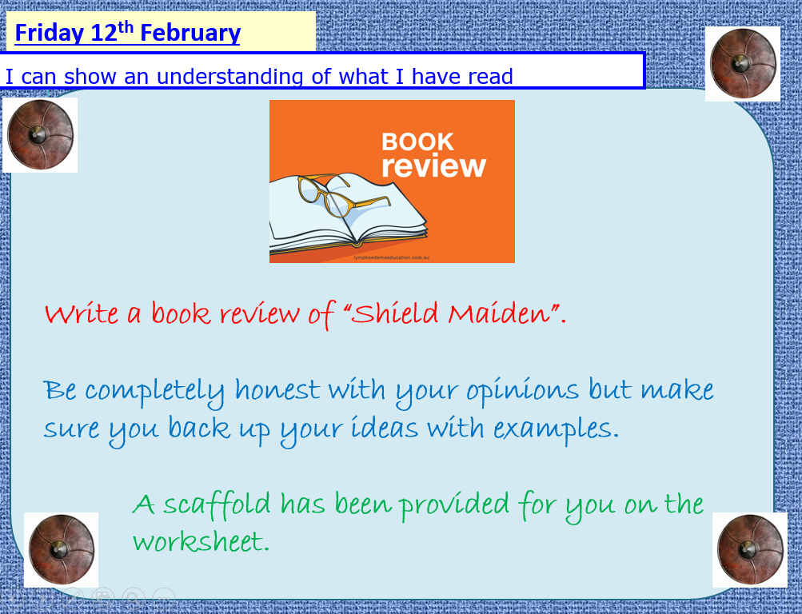

Shield Maiden by Stuart Hill
The book is about:
King Alfred the great who he was attacking vikings with the anglo saxons. He had 4 children _______________________________________________________________________________________________________________________________________________________________________________________________________________________________________________________________________________________________________________________________________
My favourite character is:
______Ara______
because when they were in battle, she used her powers to attack the vikings. She also shows them hidden places which they didnt know of _________________________________________________________________________________________________________________________________________________________________________________________________________________________________________________________________________________________________________________________________

My favourite part is:
_when the soldiers were training and Edward and Athlegifu called the soldiers boobies when the shield wall broke _____________________________________________________________________________________________________________________________________________________________________________________________________________________________________________________

My least favourite part is:
when they were training there was nothing fun or exciting ______________________________________________________________________________________________________________________________________________________________________________________________________________________________________________________

Overall, I think this book is:
Amazing and interesting because it had action, blood, magic. It is about history of King Alfred the great __________________________________________________________________________________
I would give it _____6__________ stars of out 5.

