COMPLETED WORK ON PC OR LAPTOP USING GOOGLE DOCS
1. Save your work in a place where you can locate it.
2. Log on to Google Classroom.
3. Click on assignment that the work if for - for example Maths
4. On the righthand screen there is a button that saves add/create.
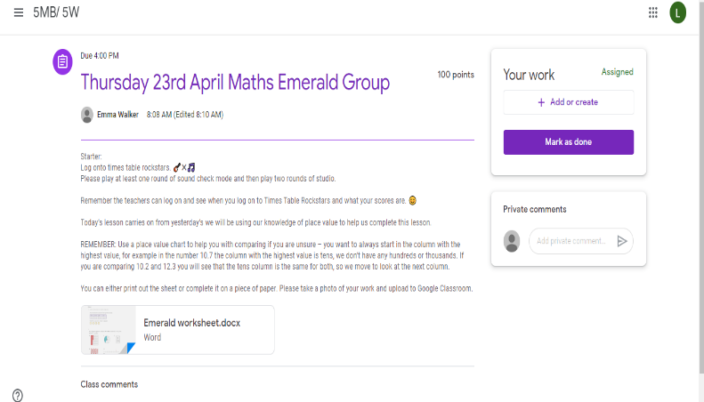

5. Click on docs or slides. Docs will open a word document and slides will open a powerpoint slide.
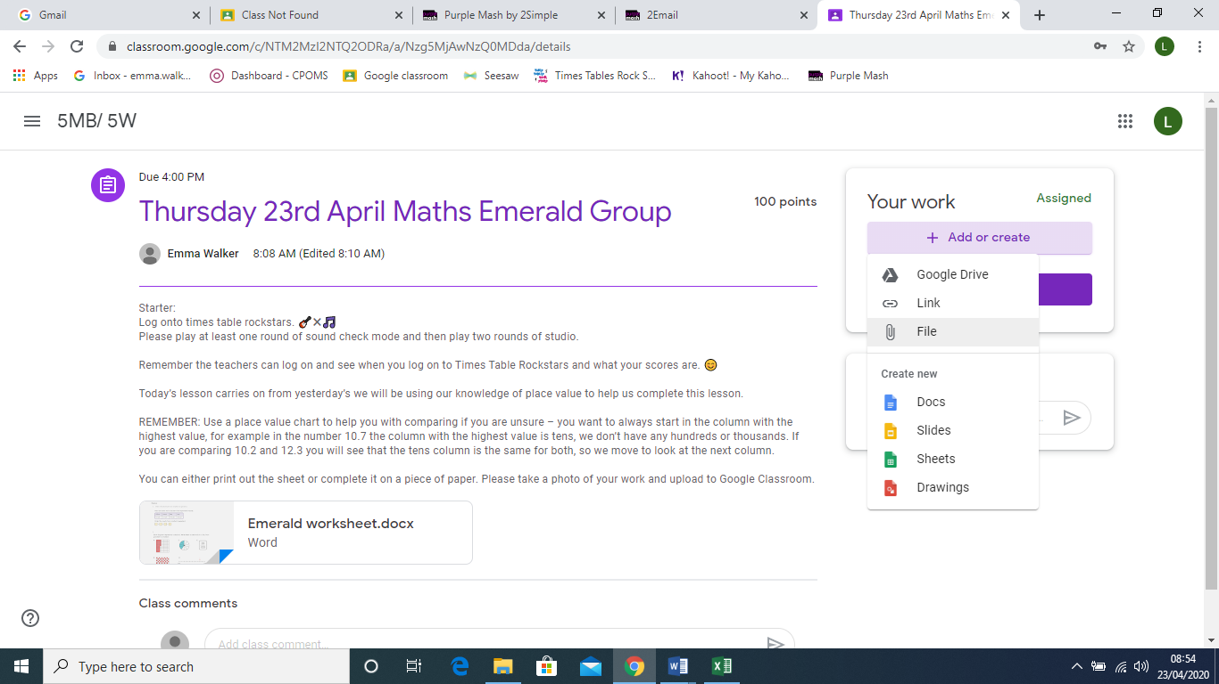

6. You will see underneath your work, it has created your document.
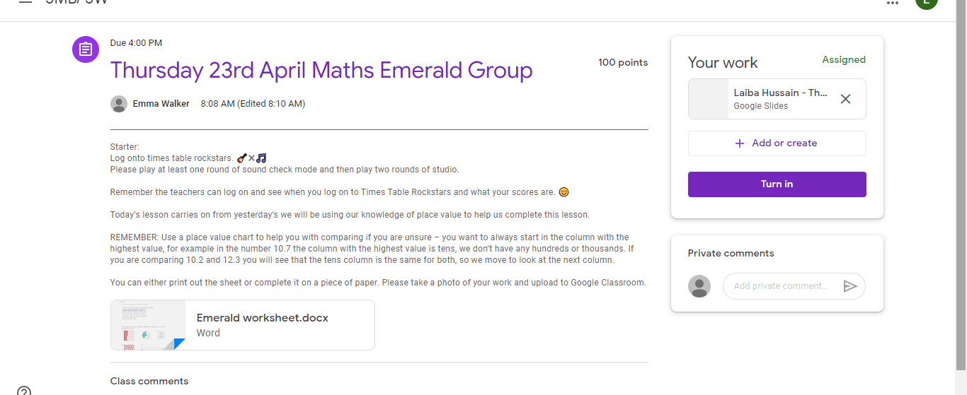

7. Click on this and it will open the blank document in a new tab. If you have clicked on docs it will open as a word document and if you click on slides it will open as a google slide document.
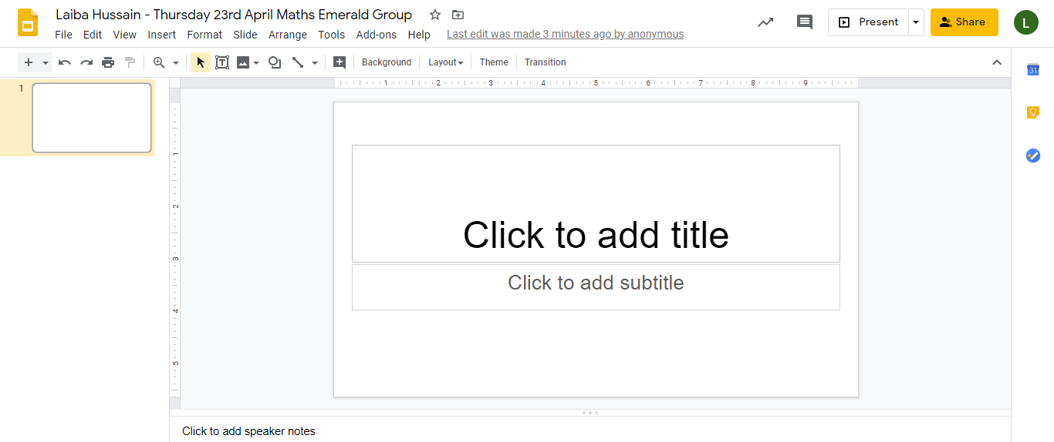

8. You should then be able to type directly into this document to complete your work. It will work just like the slides and word do at school.
9. Anything you type automatically saves.
10. Once you are ready to upload it to the assignment, go back to google classroom screen. (see pic below) and click on the purple button Turn it in. Click on this button and it will hand in your work for you.

