COMPLETED WORK ON PAPER
1. Take photo of your work either using a phone or tablet.
2. Log on to Google Classroom using either the phone or tablet you took the photo on. IT WILL NOT WORK IF YOU ARE NOT USING THE DEVICE YOU TOOK THE PHOTO OF!
3. Click on assignment that the work if for - for example Maths
4. On the righthand screen there is a button that saves add/create.
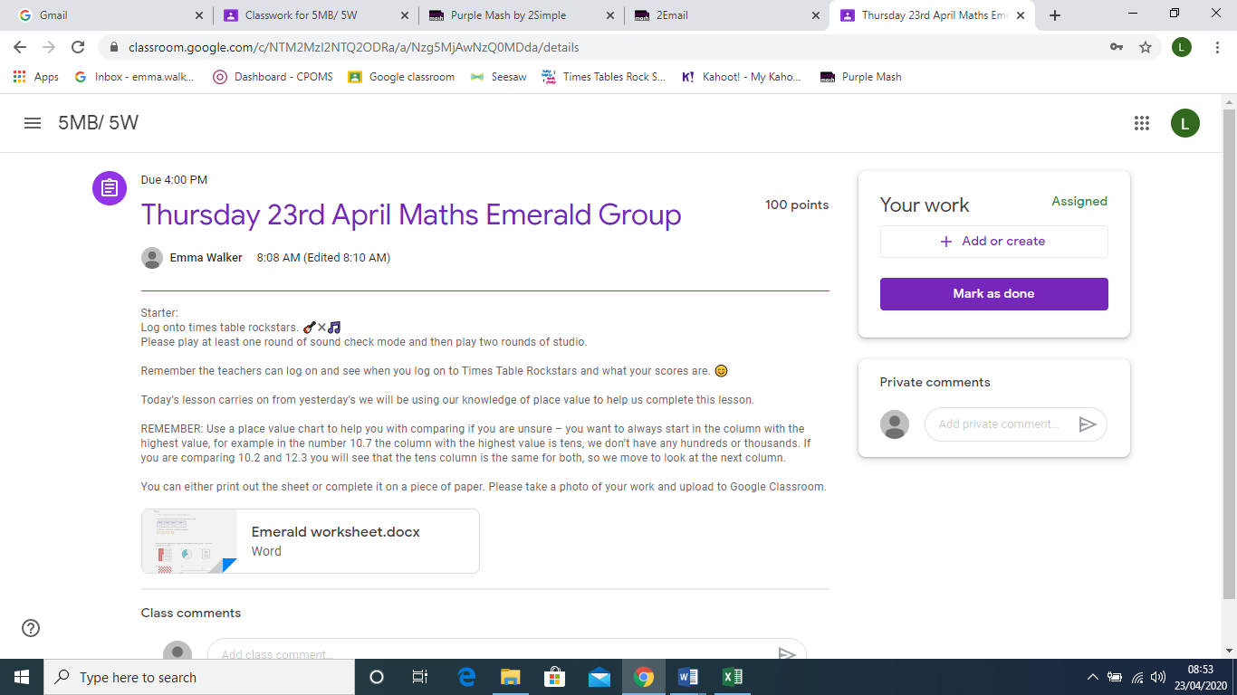

5. Click on file.
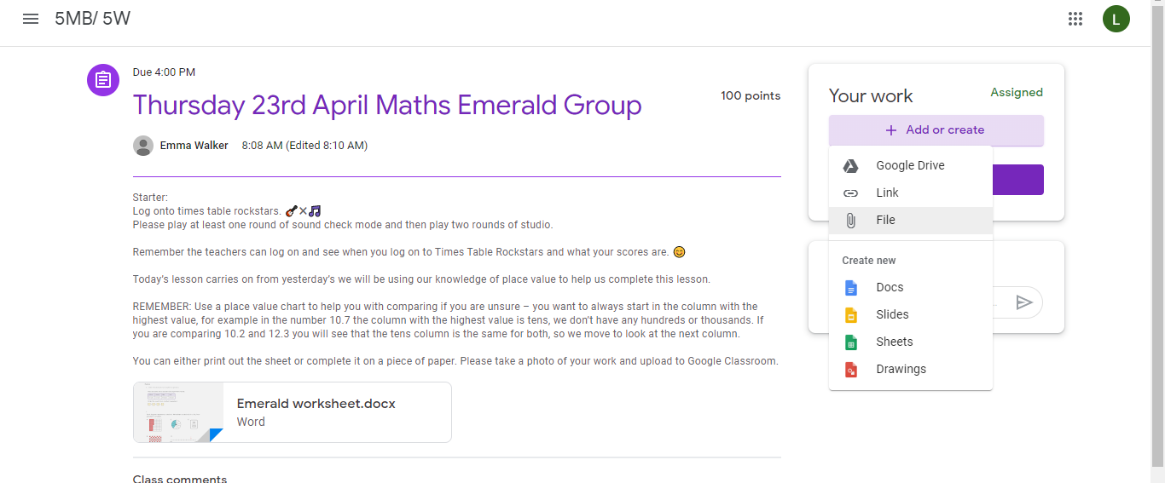

6. It will then look like this.

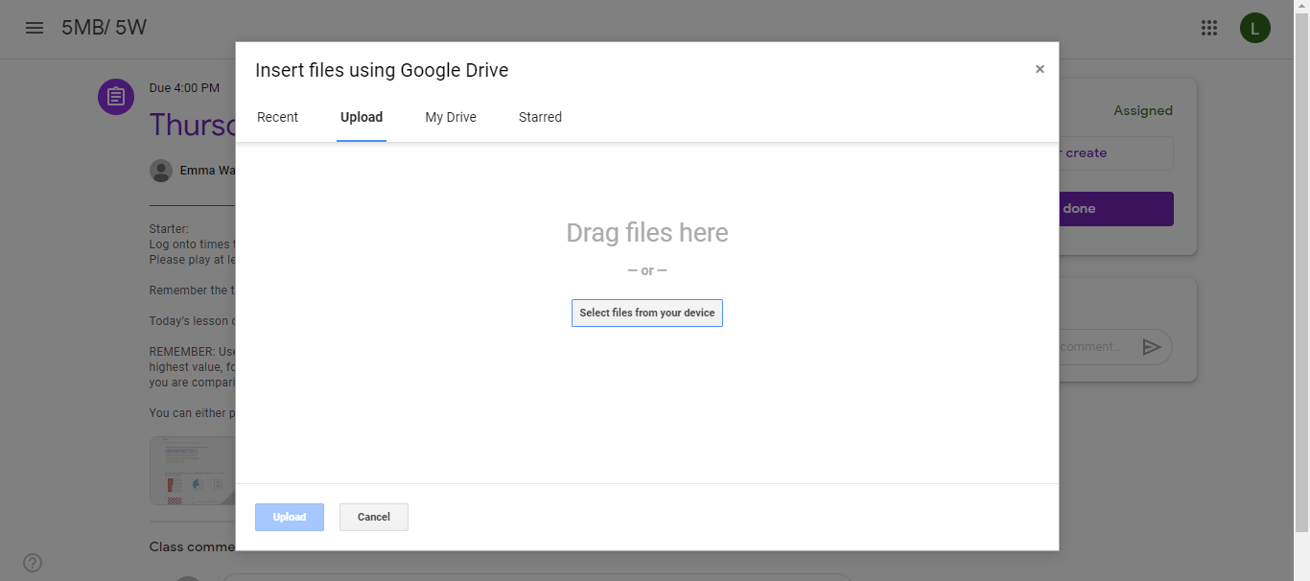
7. Click on select files from your device. This will give you the option to go to the camera roll for your photo.
8. Click on the photo you would like to upload and then click on the blue button at the bottom of the screen which says upload.
9. Once the file has been uploaded, the turn it in button will turn purple.
10. Click on this button and it will hand in your work for you.

