Friday 12th February
Writing
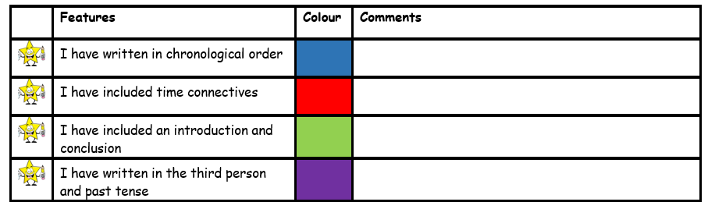
Today you are going to be writing your biography on King Arthur. I have included the subheadings you need to write under. Make sure to look at the success criteria so you remember what you need to include.

Biography of King Arthur
Early Life
King Arthur was born to Uther Pendragon. And, then he was sent to the wizard merlin to be kept safe as war was happening. Arthur was sent away to be safely grown and fed with Merlin.
Becoming King
He became king when he did an impossible mission: pulled a sword from a stone. Everyone then made him the king. And after this he proved to be a loyal and an amazing king as he led his army into battle and mostly came out successful.

Personal Life

Guinever was King Arthur’s wife and had no children. He imprisoned her later. He usually prepared for battles in his spare time and would chat with his friends.
When he died
King Arthur died on April 2, 1502. He died in battle and then being betrayed and then being seriously injured. After he was injured, he was sent away and died. He was between 35 to 50 when he died.

