Year Five
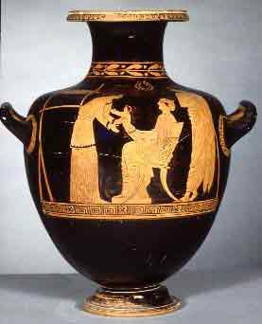
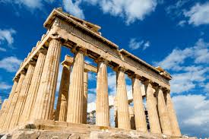
The children have made a good start in Year 5 and enjoyed an Ancient Greek Day during their first full week.
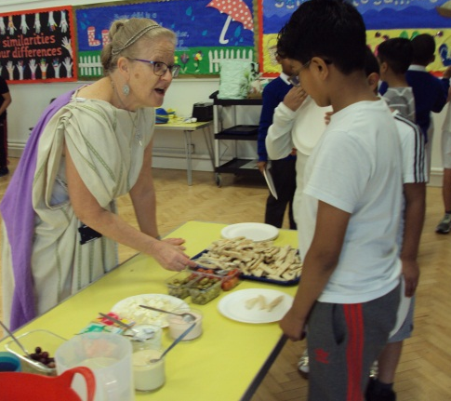
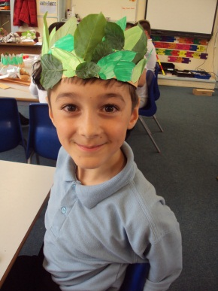
They took part in a range of activities including our own Olympic Games with javelin, shotput, sprint, standing long-jump and a marathon; making their own Greek pots, which they labelled using the Greek alphabet; head wreaths and Greek dancing.
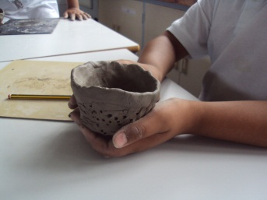
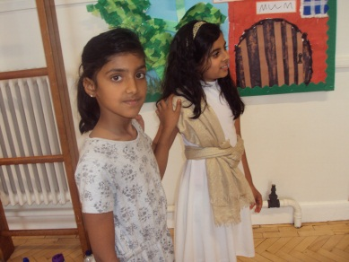
Year 5 have begun producing writing based on our Greek experience including a balanced discussion on our day and a recount as a Greek slave. The children look forward to showing you some of their writing at Target Setting in October.
In Science, 5Y will be learning about everyday materials, 5R will be studying the topic of forces and 5G will be learning about the circle of life. By the end of the year, all classes will have been taught all of the topics.
Our History topic this half term is Ancient Greece.
We will be continuing to have one session of PE outside and one session inside. This half term, with Miss Knox, we will be improving our throwing and catching skills. Please ensure your child has their PE kits on Monday for outside PE and Thurs (5G and half of 5Y) / Friday (5R and half of 5Y) for PE inside.

May we remind parents that all children are expected to complete their Maths Challenge work every night and read every night. Once these have been done and checked, their purple record books need to be signed by an adult.
Miss Rogers, Mrs Yates, Mrs Gill

