Year Four
First of all I would like to say welcome to Year Four and we hope that you had a great summer break. Year Four have returned fresh and enthusiastic for the new term, we have been very impressed with their eagerness to complete reading and math challenges over the last week. We are positive that Year Four will gain 100% consistently in reading, math and attendance challenges.

This Autumn term, Year Four will be learning about the Romans and their impact on Britain. We will use evidence to investigate how the Romans lived, why the Roman Empire was so powerful and why they invaded Britain. We have already used maps to identify the countries the Romans invaded and used books to learn about the Roman Army.

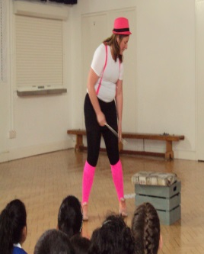
In English, we have been using our writing skills to write poems using similes and powerful adjectives. We even had an exciting visit from Mystique the Magician last Wednesday. The children have been challenged to write her a ‘Magical, Mystical Poem.’

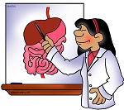
Our science topic is ‘Animals including Humans’. In this topic we will learn about food chains, types of teeth and how food travels through the digestive system.
Once again thank you for a great start to the term and please continue supporting your child with reading and maths challenges.

Thank you,
Mrs Hill-Cornwell (Year leader), Miss Drummond, Mr Sparkes and Miss Lau.

