castle_badge

**Key Stage 1**

Welcome back! Last half term was a very busy half term.

The Key Stage 1 children put on a fantastic Harvest Assembly. The children acted out the story of Kitchen Disco and all sang beautifully. Thank you for your generosity and all the food you donated. The food has been given to The One Can Trust charity based in High Wycombe and they will be giving the food to people who really need it.

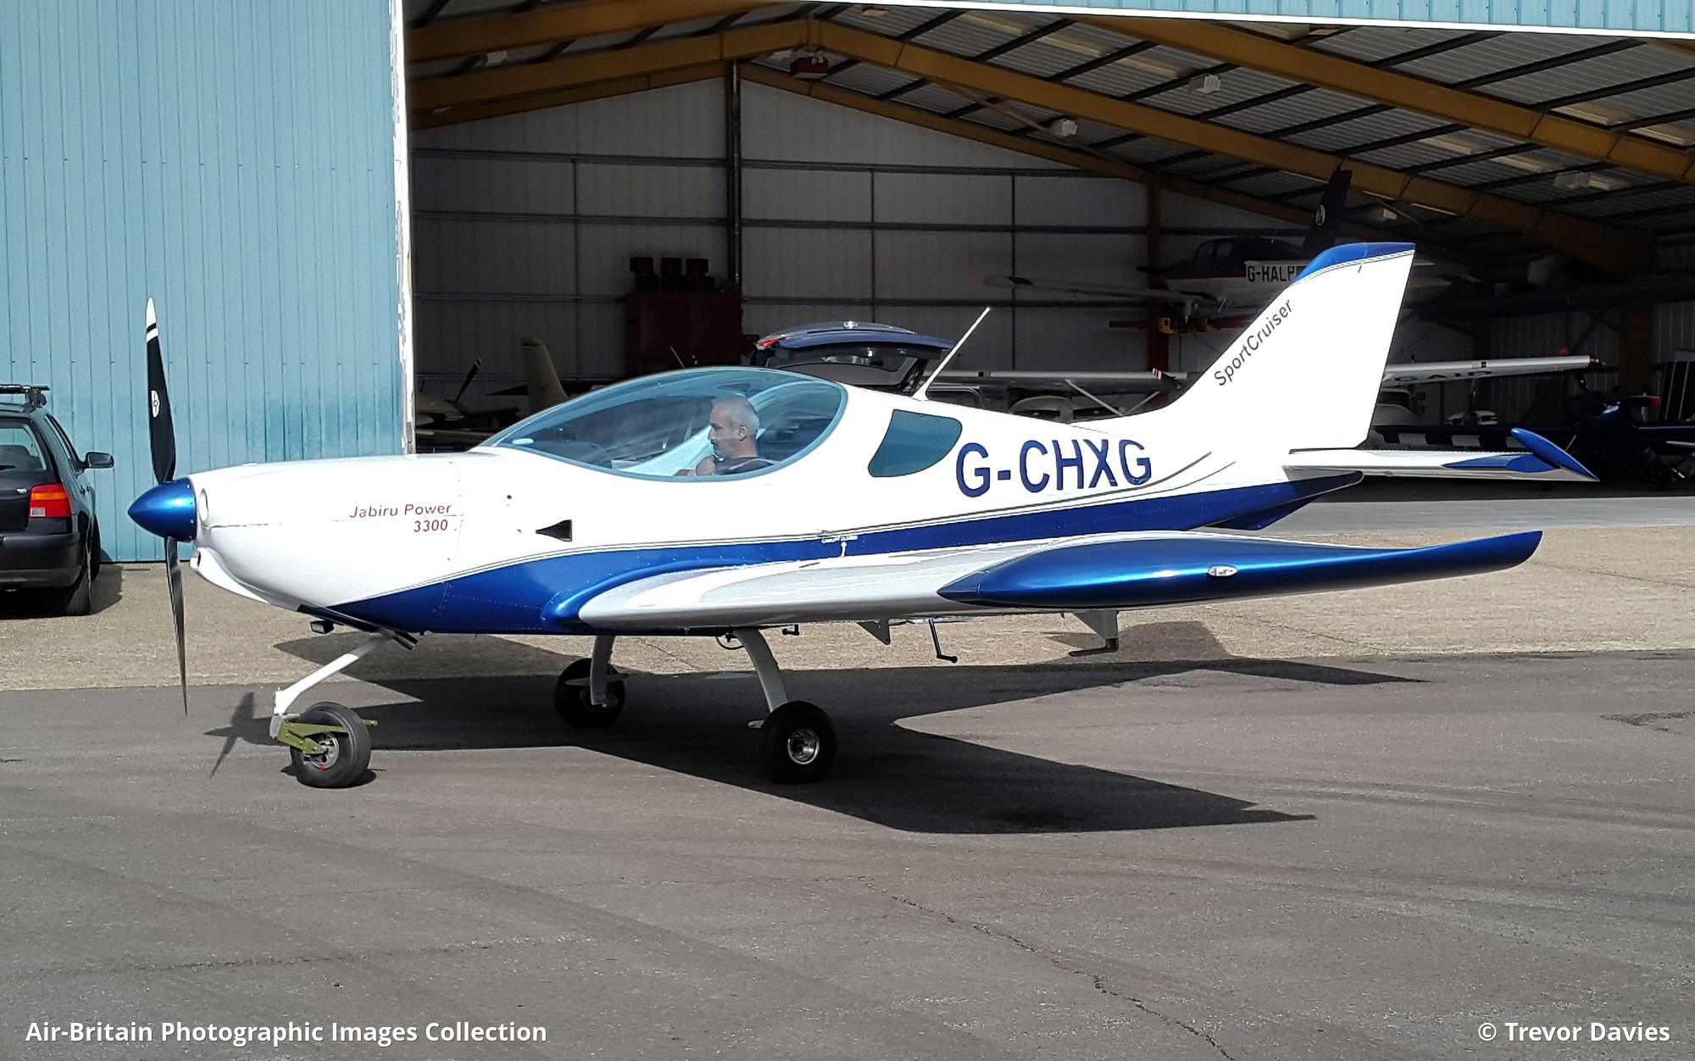

Year 2

Last half term the children enjoyed learning

about the History of Flight and had a

fantastic time at Booker Airfield. They got

to see lots of aeroplanes, helicopters and

gliders. They were able to sit in a plane and were shown how to fly it.

This half term the children will be learning about Concorde and space rockets as well as finishing making their hot air balloons.

Year 1

This half term the children will be learning about superheroes! They had a fantastic time on superhero day and all enjoyed dressing up. Thank you to those children who completed their holiday challenge, by designing their own superheroes and reading a comic book.

For our DT project this half term, please could the children bring in small cardboard boxes to make their own superheroes. Thank you.

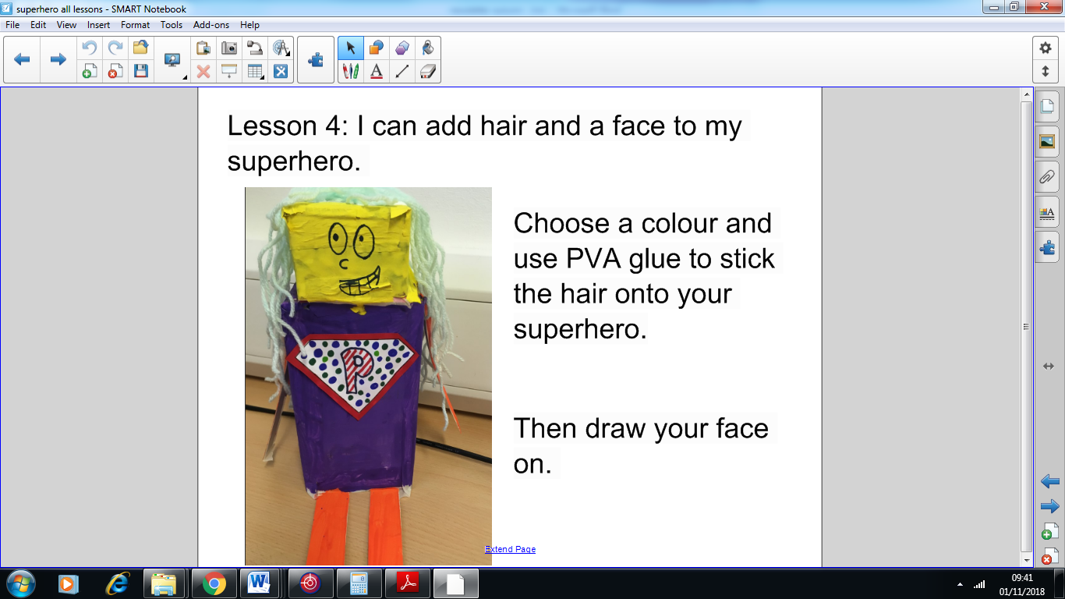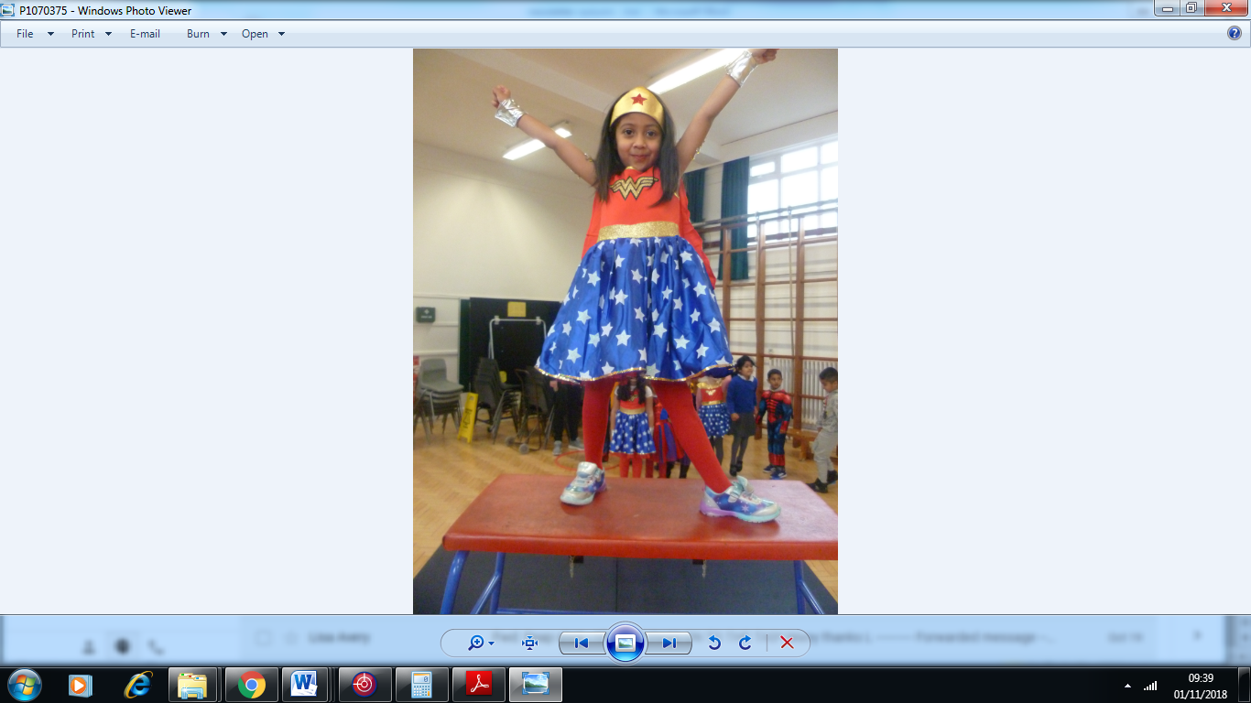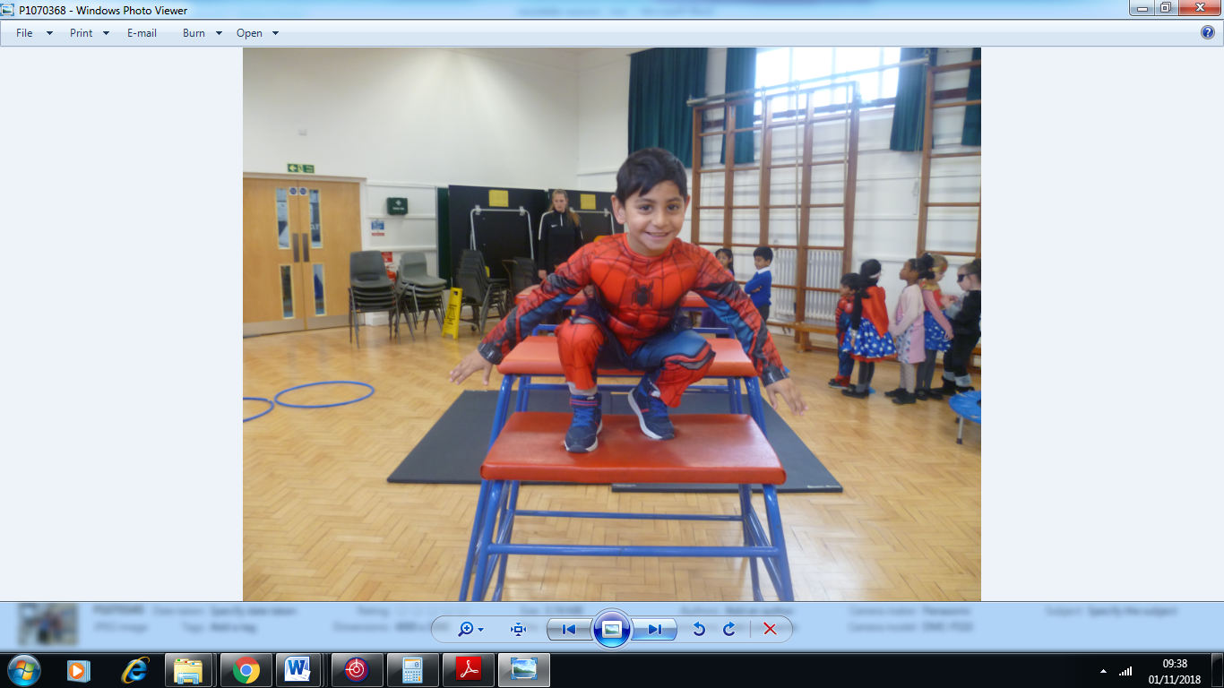

This half term we are learning about:

**Year 2**

**Year 1**

This half term we are learning about:

Numeracy

* Addition and Subtraction
* Place value
* Comparing numbers

Literacy

* Superhero stories
* Recounts
* Retelling stories
* Descriptions
* Christmas poems

Science

* Seasons

Computing

* Logging onto computers
* Recording videos using I pads.

History

* ‘Super’ People
* Florence Nightingale
* Steve Redgrave

DT

* Building own superheroes

Art and DT

* 3D hot air balloons
* 3D aeroplanes and space rockets

Science

* Keeping healthy

Computing

* Programming toys
* Moving pictures

History and Geography

* The History of flight
* Concorde
* The first moon landing
* Planning and writing about a journey

Literacy

* Stories about flight
* Retelling stories
* Writing instructions
* Writing letters

Numeracy

* Place value
* Addition and subtraction
* Money
* Multiplication and division