September 2018
Dear Parents,

As we begin another exciting year, I would like to take the opportunity to welcome you and your children back to Castlefield School. I hope that you all had had an enjoyable break.

Good Start:
Having watched the children in assemblies and having spent time around the school, it is obvious that they have come back to school ready to work extremely hard and to continue their excellent behaviour from last year.

Holiday Packs:
Thank you to all parents who heard their children read regularly throughout the holiday and encouraged them to complete some of the activities we provided. It is really noticeable who has been practising these skills and it has given your children the best possible start to their new academic year.

Attendance, Reading and Maths Challenge:
There are 3 simple ways you can support your child’s learning;
- Make sure they come to school everyday
- Make sure they arrive at school on time (by 8:50am)
- Make sure your child does their reading and maths everyday
It really makes a big difference to their learning!

Late collection:
Children in Reception, Year 1 & 2 finish school at 3:05pm. Children in Years 3,4,5,& 6 finish school at 3:15pm. Parents are expected to collect their children at these times. When parents fail to arrive on time to collect their children, they will be placed into After School Club, which incurs a charge of £4 per hour.

Target Setting Day:
On Monday 15th October there will be an opportunity for you to come with your children and meet their class teacher for an individual appointment. This meeting is extremely important as your child will be given targets for the rest of the year. A separate letter will be sent in the near future to allow you to indicate your preferred time. There will be no normal school on this day – however, all children must come to school with their parents for their appointments.

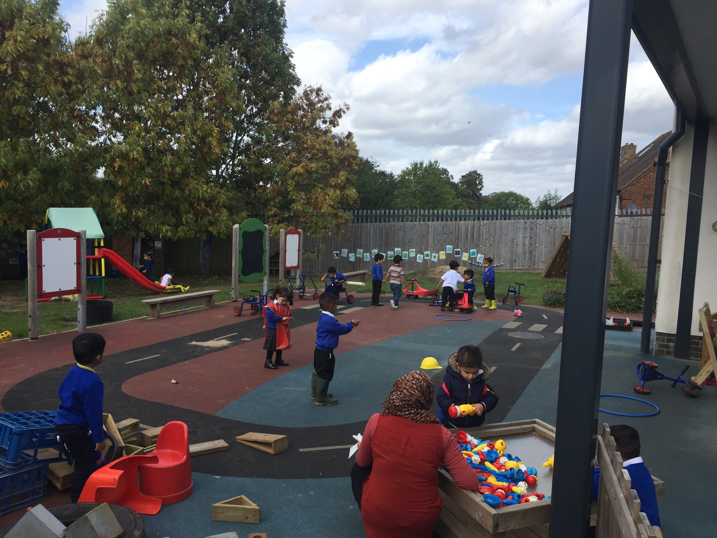 | 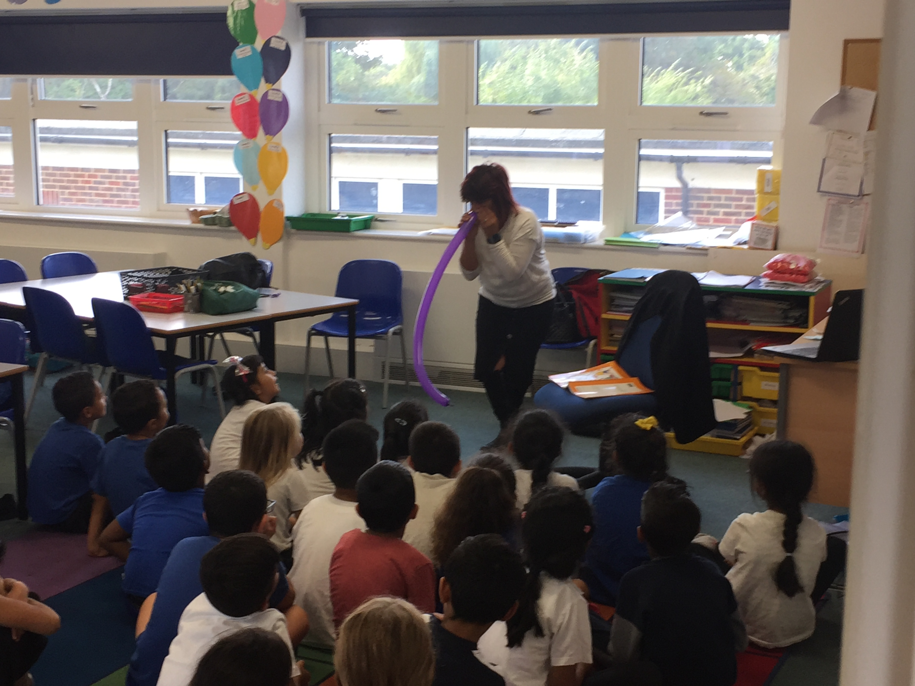 | 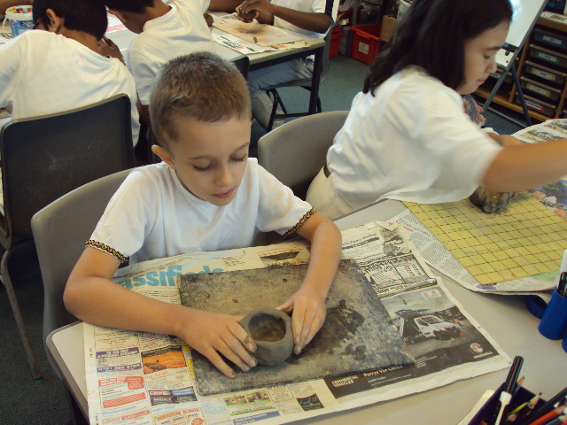
Early Years  Nursery children are settling in well! | Key Stage 1  Story telling in Y2 | Key Stage 2  Y5 Greek Day -  Pot making

Important Dates:

Monday 24th September | Y3 to Chiltern Open Air Museum
Tuesday 25th & Wednesday 26th September | Y2 trip to Wycombe Air Park
Friday 12th October | 11+ Results
 | Y4 trip to Verulamium
Monday 15th October | Target Setting Day
Thursday 18th October at 10:00am | Key Stage 1 Harvest Assembly
 | Y5 trip to RAF Halton
Friday 19th October | Last day of half term
Half Term Holiday

Monday 29th October | Children return to school
Wednesday 31st October | Deadline for secondary school applications
 | 2:30pm Phonics meeting for Reception parents
Friday 2nd November | Y6 trip to Kidzania
Tuesday 6th November | Early Years open afternoon - Reading
Tuesday 13th November | Key Stage 1 open afternoon - Reading
Tuesday 20th November | Key Stage 2 open afternoon - Reading
Thursday 6th December | Early Years Christmas Production
Wednesday 19th December | Last day of term

Yours sincerely

Andrew Kann
Headteacher

