Below are some useful tips to help with Google Classroom.

Choose the class they are in. If they are with Miss Sutcliffe for Maths they need to click on her group.
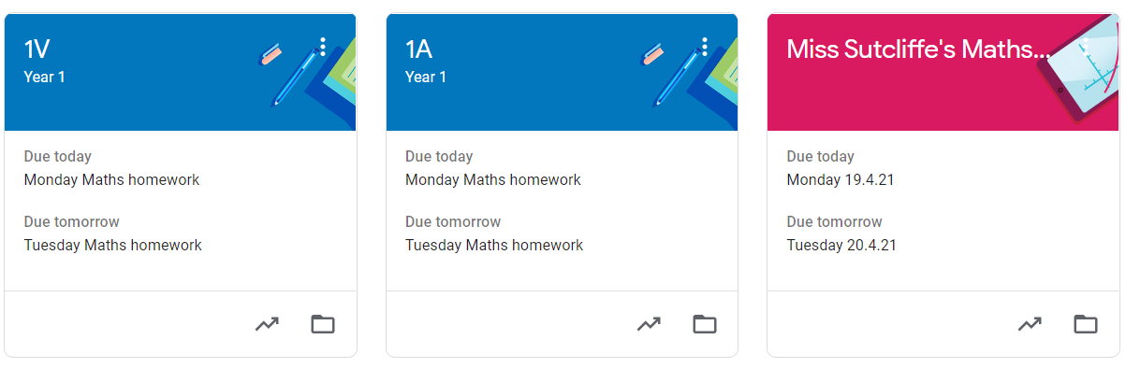

Click on the work to complete for each day.
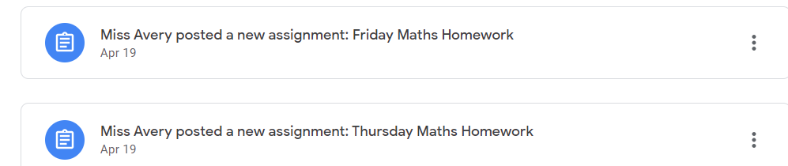

Use the text book tool to draw a box and type the answers.
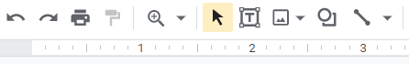

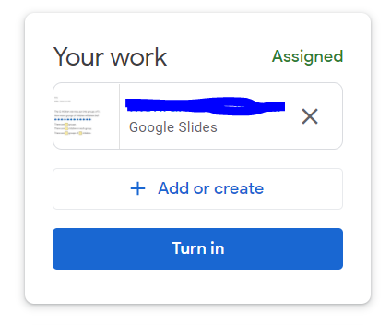
To use a pen click on the scribble tool.
Don’t forget to click ‘Turn in’ to hand the homework in.

