castle_badge

**Key Stage 1**

Welcome back! We hope that you and your children are looking forward to the year ahead.

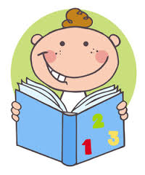

Many children completed activities in their summer holiday packs so received their certificates in assembly, we hope this hard work will continue. Please support your child to complete their Reading and

Maths challenges each week, remembering to sign your child’s book every day! Your child will be able to change their reading book when they can demonstrate that they understand what they have read.

Your child will also have spellings to learn each week.



Help your child spell the days of the week!

|  |  |  |  |
| --- | --- | --- | --- |
| Monday | Tuesday | Wednesday | Thursday |
| Friday | Saturday | Sunday |  |

Uniform

The Key Stage 1 children have returned to school looking very smart in their uniforms. Please ensure that all items of clothing are named as this will help to stop them going missing.

PE

The children will have PE on the following days:

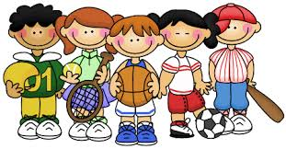

**Year 1: Monday and Tuesday**

**Year 2: Wednesday, Thursday and Friday**

Please ensure your child has their PE kit in school every day. They can take it home to be washed at the end of each half term. They should have a t-shirt, a pair of shorts or jogging bottoms and suitable shoes in their PE kit. Please name everything!

This half term we are learning about:

**Year 2**

**Year 1**

This half term we are learning about:

Maths

* Place value
* Addition
* Subtraction

English

* Stories ‘All About Me’
* Ordering and retelling
* Descriptions

Science

* All about the body
* The 5 senses

Art/ DT

* Self-portraits
* Making skeletons
* Collages

Computing

* Logging on and off computers
* Giving instructions

Science

* Materials and their properties
* Choosing suitable materials

Topic- Up, Up and Away

* The History of Flight
* Significant people and flights

Art/ DT

* 3D hot air balloons

Computing

* Logging on and off the computer
* Animations
* Programming toys

English

* ‘Flight’ stories
* Recount writing
* Story writing
* Letters
* Leaflets and posters

Topic

* Where we live
* Our local area
* Looking at maps

Maths

* Place value
* Addition
* Subtraction