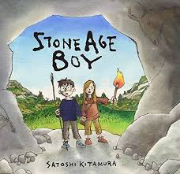**Year Three**

Year Three have made a fantastic start to the term! The children have settled in well and are enjoying being in Key Stage Two.

This term our topic is the Stone Age. We will be visiting the Chiltern Open Air Museum on Monday 24th September.

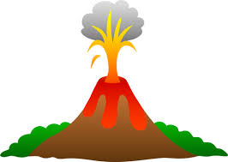

In Topic and Science we will be learning about the structure of the Earth, volcanoes and how they are formed and rocks and the rock cycle. Our first text this half term is Stone Age Boy, we have already started some impressive writing about the Stone Age and look forward to sharing it with you.

This term we are emphasising having a growth mind set, encouraging children to take risks with their learning and to become comfortable with making mistakes.

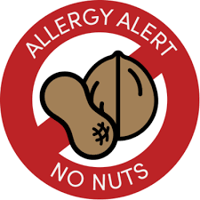Just a reminder that universal free school meals are only for children in Key Stage One. Lunch menus and money must be in by Wednesday each week for a hot meal the following week. We are nut free in Year Three, so please ensure your child’s packed lunch has no items containing nuts.



All Year Three classes have PE on Mondays and Tuesdays.

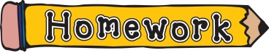The children will receive their homework and spellings every Friday, they need to complete one section each day and bring it in to show their teacher. We will have our spelling test on a Friday.

Thank you for a great start to the term. Also, please continue supporting your child with reading and maths challenges.

Mrs Sohal (Year Three Leader), Ms MacIver, Miss Farid, Miss Burrell and Mr Evans