Friday 12th February
Writing
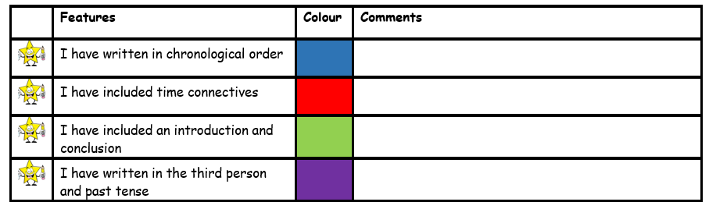
Today you are going to be writing your biography on King Arthur. I have included the subheadings you need to write under. Make sure to look at the success criteria so you remember what you need to include.

Biography of King Arthur
Early Life
Arthur was born in the medieval time around 400AD
His mum the Queen died, as soon as he was born. Then his father King Uther was killed in battle when Arthur was still a baby!
Arthur was taken by Merlin and he gave him to Sir Ecter to look after who had a son called Sir Kay

Becoming King
When Arthur was fifteen years old he came back to his town, where he found the sword in the stone. He pulled the sword out of the stone with Merlin's power without noticing and became King Arthur. He was given a special sword called Excalibur by the lady of the lake which he used in all his battles and was successful

Personal Life
Arthur married Gueniver. She was the most beautiful woman in the kingdom. One day Gueniver ran away with Sir Lancelot. King Arthur left the city to find Sir Lancelot and killed Sir Lancelot and imprisoned Gueniver . Mordred was Arthur’s son who looked after the kingdom while Arthur was away who then started controlling the country and took over the kingdom.

When he died
When Arthur returned after killing Sir Lancelot, his son Mordred took over the Kingdom. So King Arthur has a battle with Mordred to get his kingdom back which he did successfully by killing Mordred. However King Arthur got wounded in battle.
Arthur’s body was taken to Avalon and will come back when needed. Sword Excalibur was returned to the lady in the lake.

