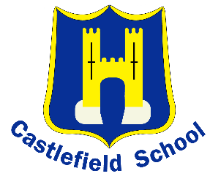 | CASTLEFIELD SCHOOL  The Middleway, High Wycombe, Bucks HP12 3LE  Tel : 01494 436018  www.castlefieldschool.co.uk

KS2 Class Teacher
required for September 2020 (or sooner if available)

Salary Grade: MPS/UPS
Full time, permanent post
Recruitment bonus for exceptional candidates
Experienced teachers and NQTs welcome to apply

Are you able to see potential in all?
Do you have the courage to make a difference?
Are you a committed teacher who is able to see past stereotypical judgements?
If so, then we could be your next place of work!

Castlefield School is a large, forward thinking and highly successful primary school in High Wycombe. We have undergone a period of significant growth in recent years, both physically and in our reputation as a school of choice. We are keen to meet enthusiastic and eager candidates and would invite anyone brave enough to confront the out-dated view of Castlefield School and to see us in action.
In order to secure the best candidates, we are offering a competitive salary packages and are willing to adapt the role to suit our mutual needs. There is a recruitment bonus available for exceptional candidates
We are confident you will find:
- Class sizes capped at 25 children
- Commitment to your CPD and professional development
- Hard-working, well-behaved and enthusiastic pupils
- A supportive working environment
- A genuine commitment to school improvement which supports a healthy work life balance

For NQTs we also offer:
- A dedicated NQT mentor and a supportive year group leaders and team
- A comprehensive induction programme
- Extended training opportunities with outstanding internal and external providers

For teachers with experience you will have the opportunities to:
- Lead and manage
- Contribute towards the professional development of others

We are looking for:
- A strong classroom teacher, committed to providing high quality learning experiences for all children
- A team player
- Organised, enthusiastic and highly motivated
- Able to provide creative, enriching learning opportunities for our children
- Committed to raising standards

Visits to our school are strongly recommended. Please contact the school office on the number above to arrange an appointment to visit. Alternatively, email: office@castlefield.bucks.sch.uk
Castlefield School is committed to safeguarding and promoting the welfare of children and young people and expects all staff and volunteers to share this commitment. References and an enhanced DBS check will be sought from the successful candidate.
Closing date: 12:00pm on Friday 27th March 2020
Interviews: Will be held on receipt of applications

