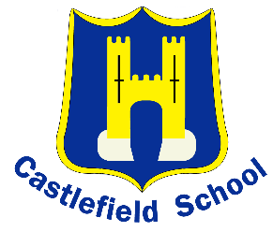

**LOWER SCHOOL**

Welcome back! Last half term was a very busy half term.

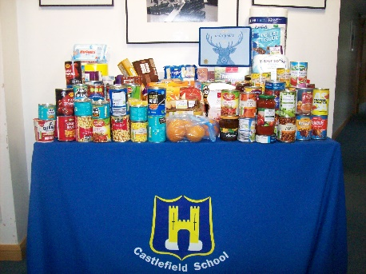

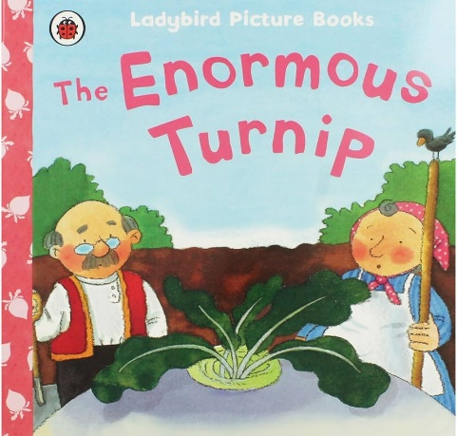The Lower School children put on a fantastic Harvest Assembly. The children all sang beautifully, Year 3 performed some fantastic poems and the Year 2 children retold the story of ‘The Enormous Turnip’ brilliantly.

Thank you for your generosity and all the food you donated. The food has been given to The One Can Trust charity based in High Wycombe and they will be giving the food to people who really need it.

Homework

Your child will be set homework on Google Classroom every day. Please support your child completing this work. When the children log into Google Classroom, they will be directed to either EdShed or TT Rockstars for their homework. Your child should have been given the usernames and passwords needed. If your child does not know their login details, please ask their class teacher.



Reading

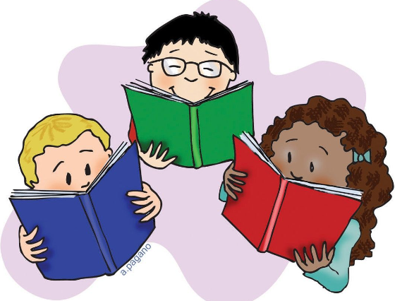

It is very important that your child reads every day. Please remember to sign your child’s book when you have listened to them read. Your child will be able to change their reading book when they can demonstrate that they understand what they have read, this may be only once or twice a week. The children can also take home another book of their choice. Please read this with your child as well.

This half term the children will get to read and listen to lots of different stories. Below are some of the books they will be reading. Please encourage your child to tell you about the stories or read other books by the same author.

**Year 2**

The Marvellous Granny Jinks and Me

Peter and The Wolf

The Enchanted wood

Charlie and the Chocolate factory

**Year 3**

The Day the Crayons Quit

The Boy who Grew Dragons

How to Train your Dragon

**Year 1**

Zog

Superworm

Aliens in Underpants save the world!

Supertato

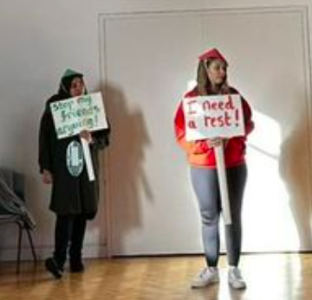

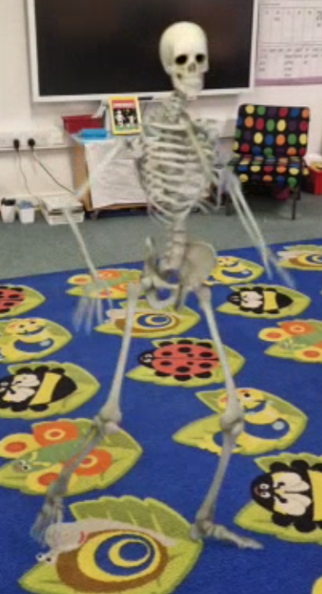

We are very pleased to say that Year 1 have settled into their new classes and new groups very well. The children have really enjoyed learning about different animals, found at home and in the wild, during Science. They have also enjoyed being able to access the Computing Suite and learning how to access and use the computers. A real highlight of

the half term has been Class Reading. The children have thoroughly enjoyed

reading and re-telling the stories and the creating story maps. The story of

‘Funny Bones’ was a year group favourite and the children were surprised to

see that Miss McMillian had managed to film a skeleton dancing in the class

when we had all left!

This term, we looking forward to our trip to Wendover Woods on the 17th

November. We shall be looking at how the trees change in autumn and

following the ‘Zog’ story trail. Payment to be made via ParentPay.

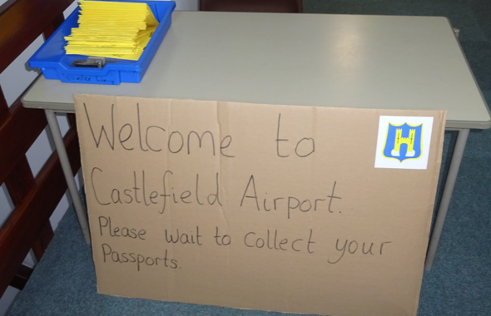



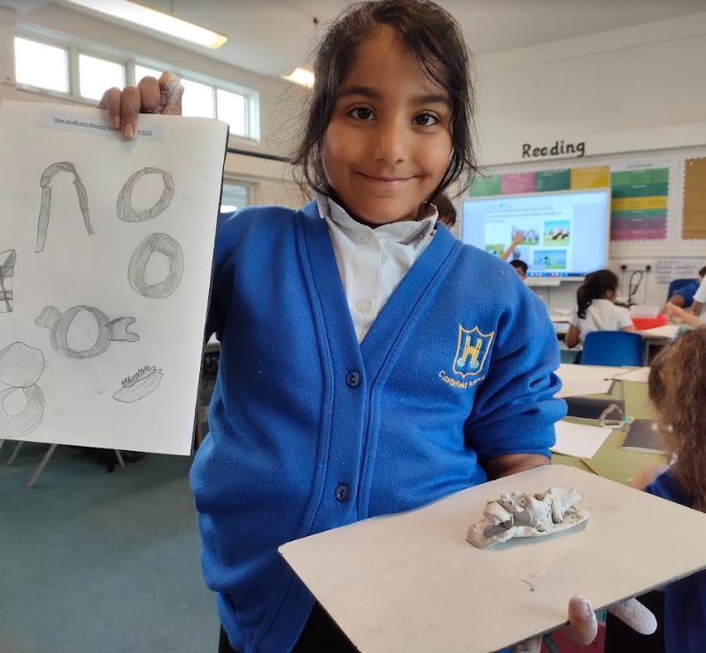

At the end of last term, the children made a sculpture in the style

of Henry Moore, using modelling clay. Previously, the children had

to design their model and then evaluate it, focusing on what had

worked well and what they could change to make it even better.

On Monday 30th October, Year Three staff dressed as crayons from

the story ***The Day the Crayons quit.*** We acted out the story,

each explaining why we were ‘fed up’ with Duncan. The children made

their own placards and we had a mini-protest! The children really

enjoyed this and it helped to bring the story to life for them all.

The children have had a very busy start to the school year. The children learned about Pop Art and created their own portraits in the style of Andy Warhol. They spent a few afternoons working scientifically and exploring the properties of different materials. They also learned how to use chopsticks as part of their Metacognition lessons. It was a tricky skill to master but they showed resilience and didn’t give up!

In History the children learned about the History of Flight. On

Thursday 2nd November the children had a special ‘Flight Day’.

The children were given passports and took part in various

activities, including designing their own flying machines! They will

learn about Amelia Earhart this half term.

**Year 2**

**Year 3**

**Year 1**